**IT2120 - Probability and Statistics**

**Lab 07**

**IT24101871 – S.R.E.G.S.L.Abhayabandara**



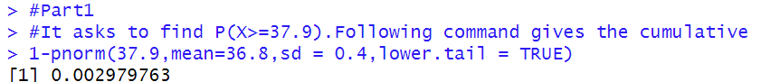



**Exercise**

